Model Development Phase Template

|  |  |
| --- | --- |
| Date | 03 October 2024 |
| Team ID | LTVIP2024TMID24818 |
| Project Title | Toxic Comments Classification For Social Media |
| Maximum Marks | 4 Marks |

# Initial Model Training Code, Model Validation and Evaluation Report

The initial model training code will be showcased in the future through a screenshot. The model validation and evaluation report will include classification reports, accuracy, and confusion matrices for multiple models, presented through respective screenshots.

# Initial Model Training Code:

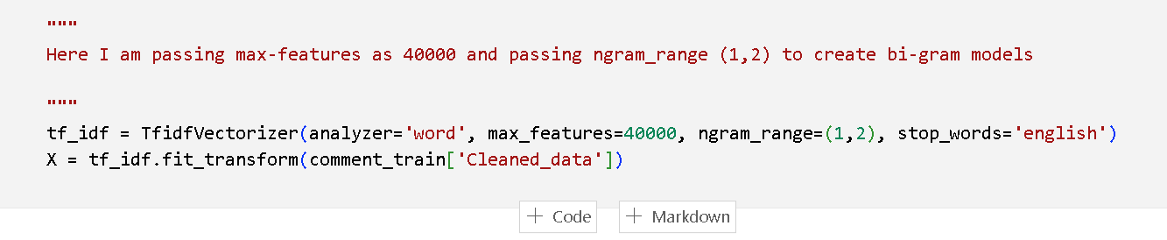

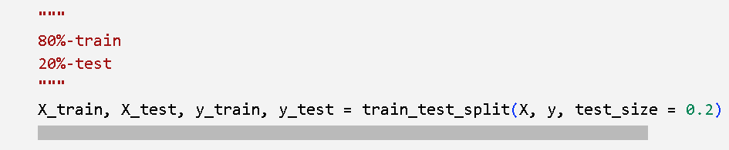

|  |  |  |  |
| --- | --- | --- | --- |
| Logistic  Regression |  | 95% |  |
| LinearSVM  model |  | 95% |  |
| Long Short-Term Memory (LSTM) Model |  | 97% |  |

**Model Validation and Evaluation Report:**